Date: Feb 5, 2024
To: Grosvenor
From: Katie Ellis, Portfolio Manager | Amy Rigby, Portfolio Sales & Marketing Manager
Re: 90 - Day Ace Leasing and Marketing Strategy
_______________________________________________________________________________________________________
INTRODUCTION:
Upon analyzing Ace Key Performance Indicators, CGM recommends the leasing and marketing strategy outlined to improve their overall brand awareness and leasing performance. The goal is to support the team in achieving their weekly leasing goals, creating more brand awareness, and structure/strategic leasing & marketing efforts.

SUMMARY:
Drawing from the insightful information in this memo and aligning with Ace's unique needs, the proposed strategy emphasizes a multi-faceted approach to enhance lead follow-up time, improve team conversion rates, intensify outreach marketing efforts, and elevate brand awareness. The strategy unfolds as follows:

- Hosting weekly team meetings to ensure all team members are engaged on leasing performance and receiving additional leasing training.
- Be prepared to be more aggressive with our specials and marketing than anticipated and launch the Marketing Incentives detailed above.
  - Tour & Win Campaign
  - Weekly Social Media Giveaways
- Complete 90-Day Outreach Plans along with creating successful and interactive events, successful housing fair, and Local Business Partnership Events.
- Rebuild social media presence to increase our following & overall engagement. Hosting monthly campaigns on social media to drive this initiative.

Where We Stand Today- Summary
- When evaluating the amount of beds absorbed by the market already compared to what is left to lease, as well as how many renters we estimate are left to sign leases, we believe that we need to average 1.39 leases to every 1 lease signed by our competitors. This means that we should be prepared to be more aggressive with our marketing and specials than anticipated.
- Below are some visuals that support the data points above:
- 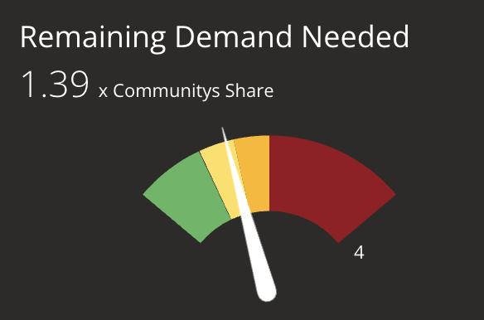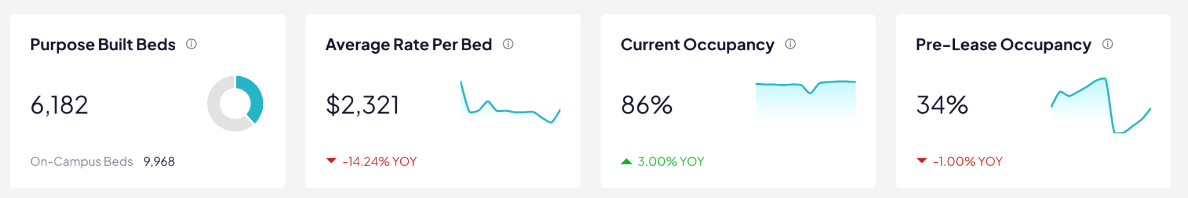
Incentives & Campaigns Moving Forward
- Tour & Win Campaign
  - Each month Ace will do a Tour & Win for a high-value prize that prospects can enter to win.
  - Prospects can choose between in-person or virtual tours conducted throughout the month of the giveaway.
  - By entering to win during the campaign, prospects can win high-value items, such as a $500 gift card, a free month of rent, AirPods Max Pros, concert tickets, and more.
  - The campaign runs from the 1st to the end of the month, providing ample time for interested prospects to stop by to tour and enter for a chance to win the monthly prize.
- Giveaways & Social Media Presence - Restructure our IG Grid to ensure it flows & incorporates brand identity. Weekly social media giveaways will help continue to build and keep followers, along with following Ace’s social media strategy. (All campaigns are Pending Approval)
  - Comment “Ace” to enter. Once they Comment we DM them “You are entered into our giveaway. To receive 10 more points to our giveaway can you complete this form?” Link Google Form Guest card.
  - DM Businesses that may want to collaborate with on Instagram & we host a giveaway for their product.
  - Posting these 5 topics weekly: Model Post (Reel/TikTok), Limited Availability or Special, Overcoming an Objection Post, Resident event post, Weekly Giveaway,
  - User-Generated Content - Message students who attend University of California Berkeley to see if you can repost their content.
  - Goal: Brand Awareness — Sign Leases
  - Weekly plans detailed below: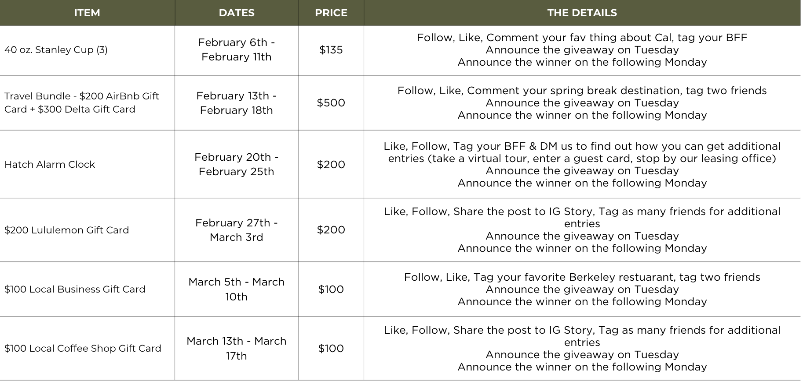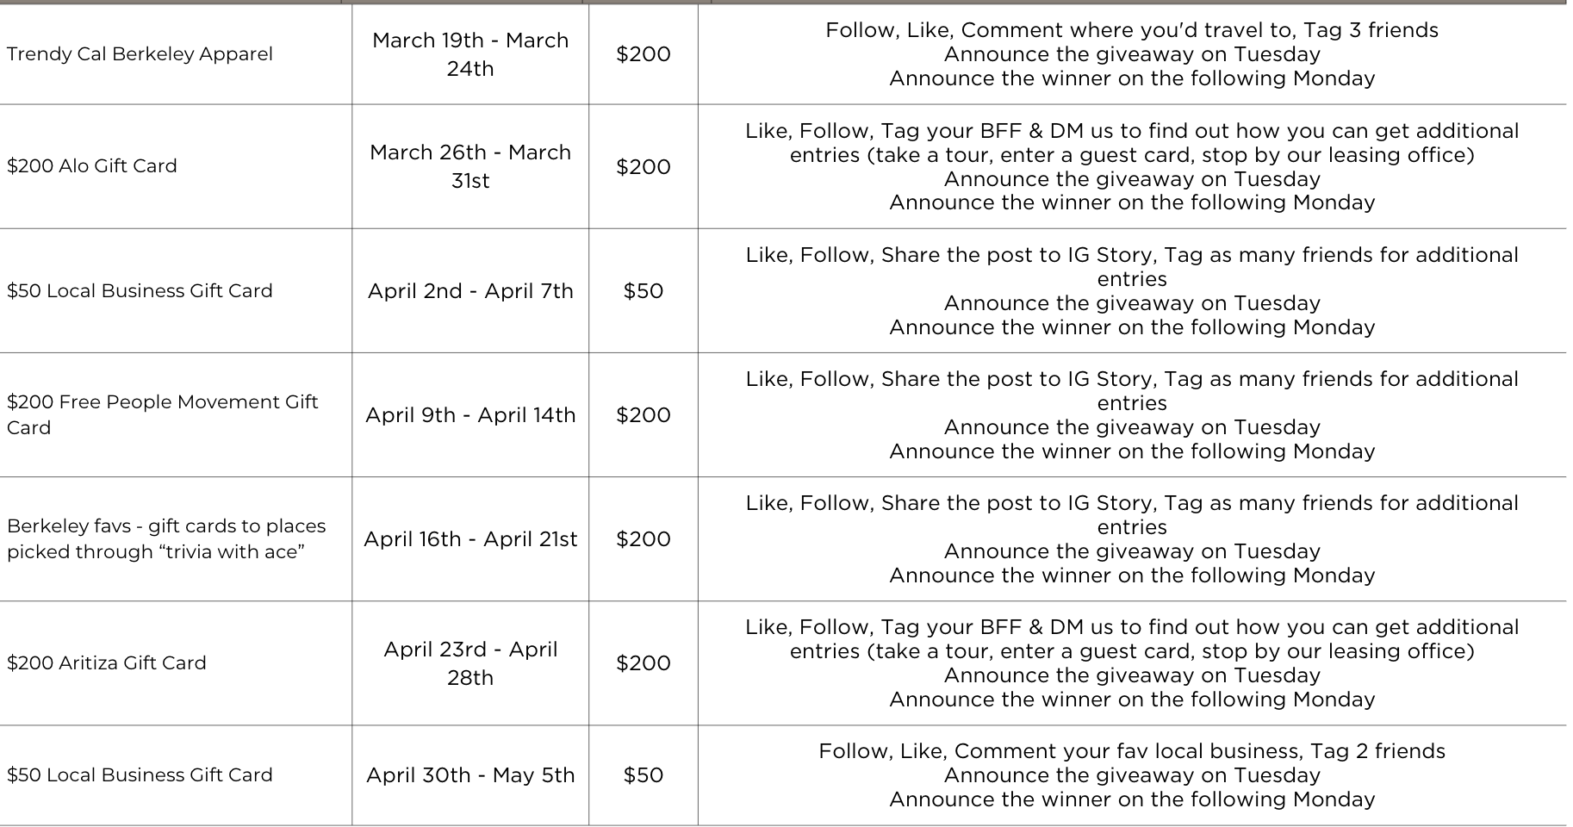

90 DAY OUTREACH PLAN
Intentional Outreach Marketing - Perform this 90 day outreach marketing plan during peak hours on campus hitting on campus hot spots. Ensure this marketing is intentional & aligns with brand authenticity. Collaborate with a local business weekly to complete an elevated tabling event. Additionally, we should be tracking the leads we are receiving from each outreach effort.
Goal: Brand Awareness & Increase Lead Pipeline & Schedule Tours
Timeline | Details
Days 1- 3 | Feb 1st - 4th: Launch social media rebranding following our social media strategy plan and launch our “Trivia with Ace” on Cal’s campus.
Days 4 - 7 | Feb 5th - 7th: Donuts passed out by Greek row in the late morning. Night time outreach starting with bar promos and late night marketing with branded giveaways (cookies, flowers, etc). We will look to collaborate with local bars for sponsored events.
Days 8 - 10 | Feb 8th - 11th: Visit various clubs and organizations events held throughout the week on campus to bring them flowers, milkbomb, etc. Flyers around campus advertising “Chocolates on us” QR Code signup on campus.
Days 11 - 14 | Feb 12th - 14th: Pass out roses on campus on February 14th with a branded QR tag that says “We have a crush on you, scan to find out who.” Host a larger social media giveaway during this time so those who scan will want to follow to join.
Days 15 - 17 | Feb 15th - 18th: Work with local pizza shop to distribute box flyers with specific promo codes for our incentive to track results coming in from those ordering throughout Valentine’s Day weekend.
Days 18 - 21 | Feb 19th - 21st: Continue our “Trivia with Ace” on Cal’s campus.
Days 22 - 24 | Feb 22nd - 26th: Visit various clubs and organizations events held throughout the week on campus to bring them flowers, branded cookies, bakery goods,
Days 25 - 28 | Feb 27th - 29th: Partner with local coffee shop to promote this local business. Pick up tabs for the first 15 orders, along with using our branded coffee sleeves/napkins in their store throughout these three days.
Days 29 - 31 | Mar 1st - 5th: Pop up on campus or close to it for dog photoshoots. Hire a photographer and host a “booth” and have people stop by to get a professional photo with their dog. During that, we can push our pet friendly initiatives.
Days 32 - 35 | Mar 6th - 8th: Continue our “Trivia with Ace” on Cal’s campus.
Days 36 - 38 | Mar 9th - 12th: Greek life efforts, passing out branded Ace boxes with a custom invitations to attend our event with local yoga studio, offering 1 free class to those that attend and mention our box.
Days 39 - 42 | Mar 13th - 15th: Night time outreach for late night marketing with branded promo items and small “goodie” bags, along with tabling outside of popular places at night. Continue our “Trivia with Ace” to get content during these bar promos.
Days 43 - 45 | Mar 16th - 19th: Polaroid film on us - Set up “photobooth” style of shoot and place QR Code branded Ace Berkeley sticker on the back of the portrait
Days 46 - 49 | Mar 20th - 22nd: Pop Up on campus to DIY friendship bracelets - various locations throughout these 3 days
Days 50 - 52 | Mar 23rd - 25th: Send DMs & emails to followers about where to find us on campus for our exclusive popup (“polaroid photo on us” or “make your own bouquet” with Ace).
Days 53 - 56 | Mar 26th - 28th: Continue our “Trivia with Ace” by the Gourmet Ghetto to incorporate more locals due to most Cal Students being gone for Spring Break.
Days 57 - 59 | Mar 29th - Apr 2nd: Engage in guerrilla marketing: flyers, stickers, and utilizing the DOT in high-traffic areas to ensure our collateral is around Cal’s campus for the student’s return from Spring Break.
Days 60 - 63 | Apr 3rd - 5th: Engage in guerrilla marketing: flyers, stickers, and utilizing the DOT in high-traffic areas to ensure our collateral is around Berkeley for the student’s return from Spring Break.
Days 64 - 66 | Apr 6th - 9th: Night time outreach for late night marketing with branded promo items and small “goodie” bags, along with tabling outside of popular bars or food spots at night. Continue our “Trivia with Ace” on during these bar promos.
Days 67 - 70 | Apr 10th - 12th: Donut shops to the athletic department to promote brand awareness and see if any athletes are still needing housing for Fall
Days 71 - 73 | Apr 13th - 16th: Another round of Polaroid film on us - Set up “photobooth” style of shoot and place QR Code branded Ace sticker on the back of the portrait
Days 74 - 77 | Apr 17th - 19th: Pass out cookie platters from Insomnia when we stop by the Greek Houses. Add a custom note on each platter to advertise a group discount campaign during these efforts.
Days 78 - 80 | Apr 20th - 23rd: Pop up near campus to DIY your own trucker hats. Add in additional outreach efforts on campus asking students questions about UC Berkeley (their fav restaurants, best place to get game day apparel, fav local business, etc.) for video content by playing on “Vogue's 72 questions.”
Days 81 - 84 | Apr 24th - 26th: Branded Coke Bottles on campus - passing out in high traffic areas using the ice cream bike to keep them cold (if approved)
Days 85 - 87 | Apr 27th - 29th: Visit various clubs and organizations events held throughout the week on campus to bring them flowers, milkbomb, etc.
Days 88 - 90 | Apr 30th - May 2nd: Final prep pop up throughout popular spots by campus. Advertise late spring/summer move ins and signing before they go home for the summer.

ADDITIONAL STRATEGY RECOMMENDATIONS:
- Weekly Team Meetings: Host weekly meetings with all team members, training and focusing on the execution of Leasing strategies, Sales Calls, Tour Closing, & follow up procedures. Goal: Improve Team Conversions
  - Email Signed Team Meeting Agenda to PM & PSM.
  - Meeting Agenda
  - Cardinal Way of Leasing Resources
- Open House: Host elevated Open House events around Key Dates. Goal: Sign New Leases & Drive Tour Traffic
  - 1x/Month in addition to the Open House after the Spring Housing Fair
  - Each Open House Needs to have a Theme.
- Call Tracker Logs + Follow-ups: Follow ups need to help push leads through the leasing process. All follow ups should end with questions to prompt responses. To ensure that
  - Text Templates added to Thatkey Examples
    - Tour Confirmation Text
  - Complete Weekly Lead Conversion Notes
  - Goal: Improve Lead Conversions – Scheduling more tours at the leasing office.

